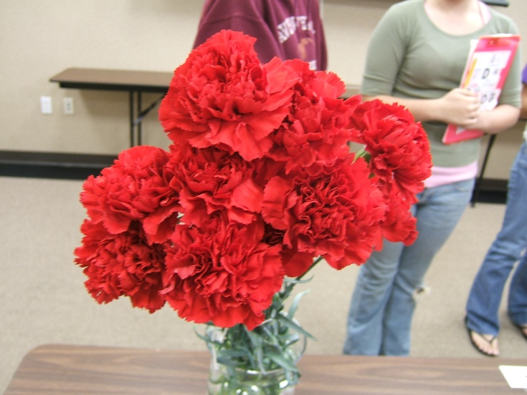
Carnations:
- 90 degree angle
- Stems straight. NOT erect
- Caylax can’t be split
- Uniform
- Shape
- Vibrant color
- Fuller blooms
- NO over mature/ saggin!!

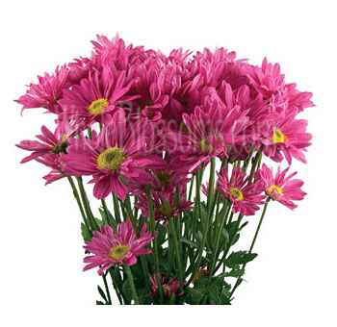
Pom Pom:
- Top like a disk
- Darker green/ bigger leaves = healthiest
- Same height
- Spray formation- uniformity
- NO broken anything!!

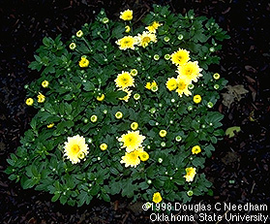
Florist Chrysanthimums:
- Round heads
- Evenly mature
- Symmetrical
- Plant in circle
- Flower heads at same height
- If there are missing petals, DEDUCT POINTS!
- Flower size
- Uniformity
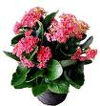
Kalanchoe:
- Flowers above leaves
- Symmetrical
- Color
- Erect stems of flowers
- NO water residue or spray
- Flower-same height & maturity
- NO discolored leaves!!!

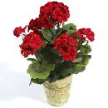
Geranium:
- Above leaves
- Same # of florets in blooms= same size
- Blooms mature at same age
- Leaves NOT everywhere = compact
- Centered in container & strong stems
- Poor leaf development= BAD!
- Leaf color= turgid=greenest
- Balance
- NO insect or mechanical damage.
- No debris in pot

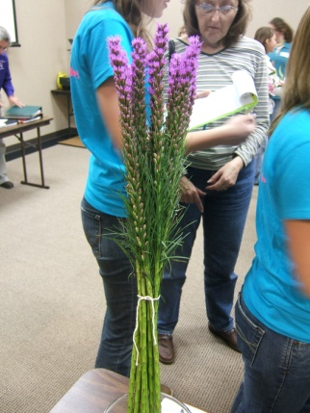
Line Flowers (Liatris / Larkspur / snapdragon):
- Openness of over mature blooms
- Uniformity
- Straightness
- Missing florets!!!!!!
- Amount of blooms along stems

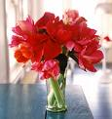
Stargazer Lily & Amaryllis
- Mature
- Size of blooms
- NO DAMAGE!!
- Emasculation -(pulled off pollen)

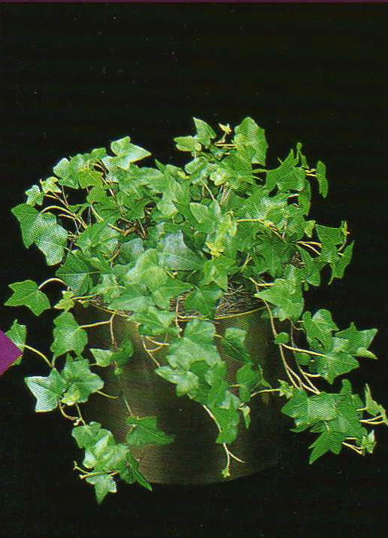
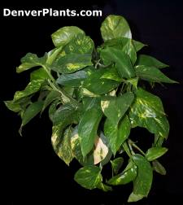
Ivy
- Uniformity
- NO DAMAGED LEAVES!!
- Symmetrical
- NO bug / insect damage
- Dense growth pattern/canopy
- No vines broken
- No dirty foliage/leaves
- No brown tips

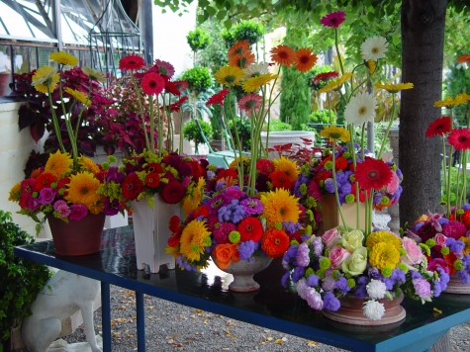
Designs:
- No over mature
- NO missing petals
- Spacing is everything!!!
- Visual balance
- Flower quality is IMPORTANT!
- Balance and proportion
- Effective Focal Point
- Floral Foam MUST be covered in design!!!
- No extra weird stuff sticking out

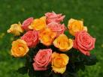
Roses:
- NO brown petals
- NO loose petals
- Bull heads (fat rose head)
- Openness
- NO crooked stems
- Stem thickness
- NO mildew
- NO brown leaf
- Weak- DEDUCT POINTS!!
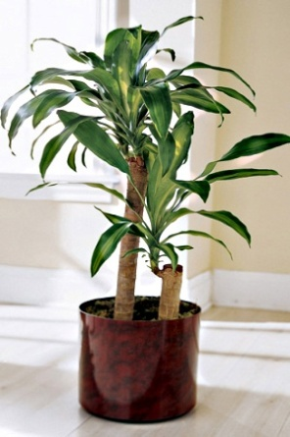
Corn Plant
- Bigger in size = better
- No leaf tip burn
- Symmetrical shaped
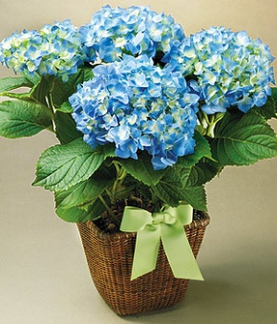
- No crooked trunk
Hydrangea
- Full foliage
- symmetrical

